**Exercise 1: Setting Up JUnit**

**Scenario:**

You need to set up JUnit in your Java project to start writing unit tests.

**Steps:**

1. Create a new Java project in your IDE (e.g., IntelliJ IDEA, Eclipse).

2. Add JUnit dependency to your project.

3. Create a new test class in your project.

**STEP 1 – CREATING A NEW JAVA PROJECT**

* Created a project named “JUNIT TESTING”.

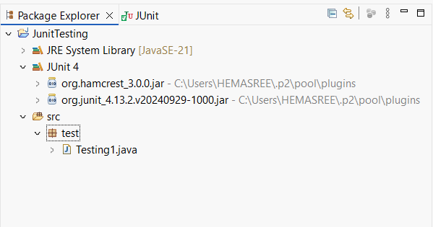

**STEP 2 – ADDING JUNIT DEPENDENCY**

* Added Junit Dependency using Build tools



**STEP 3 – CREATING A NEW TEST CLASS**

* Created a new test class named “Testing1.java” under the Junit testing project

**Code:**

|  |
| --- |
| **package** test;  **import** **static** org.junit.Assert.*;  **import** org.junit.Test;  **public** **class** Testing1 {  @Test  **public** **void** test() {  **int** result = 2 + 3;  *assertEquals*(5, result);  }  } |

**Output:**

